LUX13HS, LUX19HS, LUX160

A family of High Speed CMOS Image sensors with low noise Global Shutter pixel based on patented LUXIMATM CDS-in- pixel technology. The family includes 1Mpix, 2Mpix (full HD), and 16Mpix (4K) sensor developed for machine vision, 3D imaging, TV sports, and industrial markets. The sensors share similar package allowing customers to design 3 cameras with essentially one design.
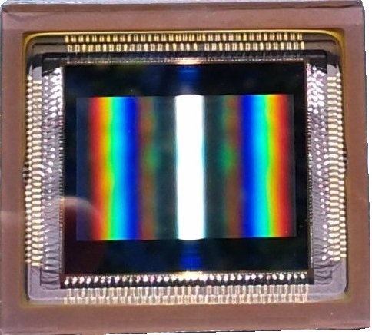

 |  | LUX13HS |  | LUX19HS |  | LUX160
Optical format |  | 4/3” |  | 4/3” |  | 4/3”
Active resolution |  | 1280x864 |  | 1920x1080 |  | 4704x3424
Pixel type |  | 7T shutter with CDS |  | 7T shutter with CDS |  | 5T shutter with CDS
Pixel pitch |  | 13.7um |  | 10um |  | 3.9um
Saturation/ Noise |  | 20,000e-/ 14e- |  | 15,000e-/ 10e- |  | 10,000e-/ 5-10e-
Responsivity |  | 25V/Lux-s @ 550nm |  | 20V/Lux-s @ 550nm |  | 4.5V/Lux-s @ 550nm
QE |  | >45% @ 550nm |  | >50% @ 550nm |  | >50% @ 550nm
Conversion gain |  | 70 uV/e- |  | 80 uV/e- |  | 120 uV/e-
DSNU |  | 4 mV r.m.s. |  | 4 mV r.m.s |  | 4 mV r.m.s.
PRNU |  | <1.5% rms |  | <1.5% rms |  | 2% rms
Shutter efficiency |  | 99.9% |  | 99.9% |  | 99.9%
Nominal Frame Rate  @ Full resolution |  | 3800 Frames/s |  | 2500 Frames/s |  | 350 Frames/s
Column ADC |  | 10b |  | 10b |  | 10b
Data Output |  | 80 LVDS ports 10b  64 LVDS ports 8-b |  | 80 LVDS ports 10b  64 LVDS ports 8-b |  | 80 LVDS ports 10b  64 LVDS ports 8-b
Multiplexed Output |  | YES |  | YES |  | YES
Nominal clock rate |  | 133 MHz |  | 87.5 MHz |  | 90 MHz
Power supply |  | 3.3V/1.8V |  | 3.3V/1.8V |  | 3.3V/1.8V
Power consumption |  | 3W |  | 2.5W |  | 3W
Package |  | 345uPGA, 361uPGA |  | 345uPGA |  | 361uPGA, 345uPGA
Color Filter |  | RGB or Mono |  | RGB or Mono |  | RGB or Mono

